Free songs and resources  for early learning  through community singing  www.SingWithOurKids.com |  |  | 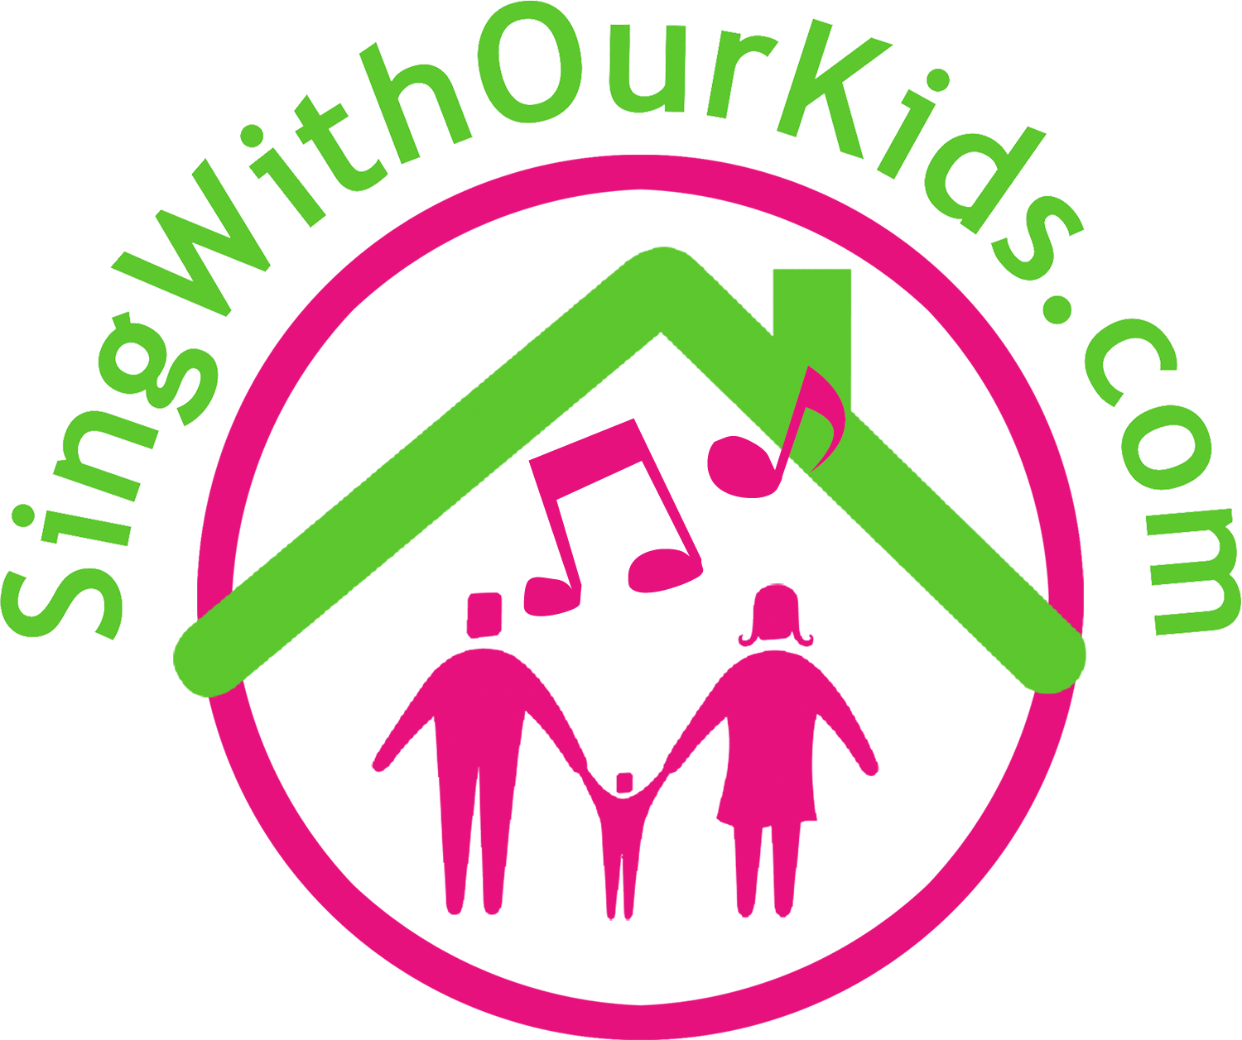  Passport  Sing With Our Kids  Passport to Early Learning
Free songs and resources  for early learning  through community singing  www.SingWithOurKids.com |  |  | Passport  Sing With Our Kids  Passport to Early Learning

Sing Around the Island
and
Fill Your Passport!
Get Your Passport Stamped
At every event
and receive a free CD of songs
you can sing with your family!

Get one stamp
at each family event
and
5 stamps
for attending parent talk!

Sing Around the Island
and
Fill Your Passport!
Get Your Passport Stamped
At every event
and receive a free CD of songs
you can sing with your family!

Get one stamp
at each family event
and
5 stamps
for attending parent talk!

